library(naivebayes)

naivebayes 0.9.6 loaded

library(dplyr)

Attaching package: ‘dplyr’

The following objects are masked from ‘package:stats’:

filter, lag

The following objects are masked from ‘package:base’:

intersect, setdiff, setequal, union

library(ggplot2)

library(psych)

Attaching package: ‘psych’

The following objects are masked from ‘package:ggplot2’:

%+%, alpha

data<-read.csv(file.choose(),header=T)

str(data)

'data.frame': 209 obs. of 8 variables:

$ X : int 1 2 3 4 5 6 7 8 9 10 ...

$ time : int 10 30 35 99 185 204 210 232 232 279 ...

$ status : Factor w/ 5 levels "","1","2","3",..: 4 4 3 4 2 2 2 4 2 2 ...

$ sex : int 1 1 1 0 1 1 1 0 1 0 ...

$ age : int 76 56 41 71 52 28 77 60 49 68 ...

$ year : int 1972 1968 1977 1968 1965 1971 1972 1974 1968 1971 ...

$ thickness: num 6.76 0.65 1.34 2.9 12.08 ...

$ ulcer : int 1 0 0 0 1 1 1 1 1 1 ...

xtabs(~X+time,data=data)

data$age<-as.character(data$age)

data$sex<-as.character(data$sex)

str(data)

pairs.panels(data[-1])

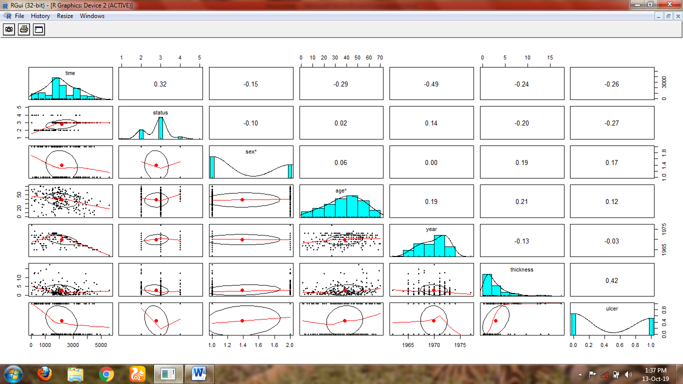

data %>%

ggplot(aes(x=X,y=time,fill=X))+geom_boxplot()+ggtitle("Boxplot")

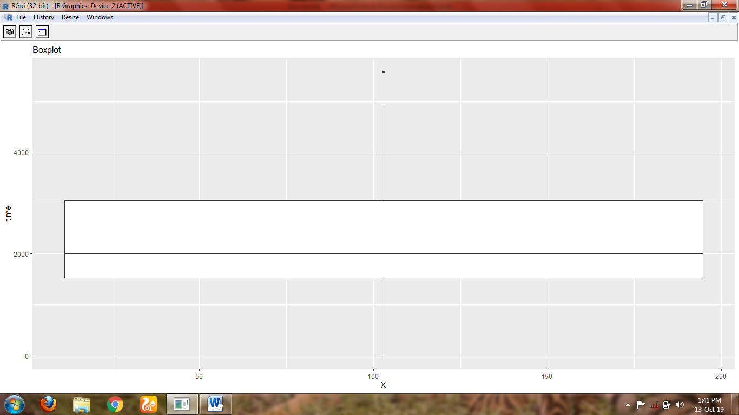

data %>%

+ ggplot(aes(x=time,y=status,fill=time))+geom_boxplot()+ggtitle("Boxplot")

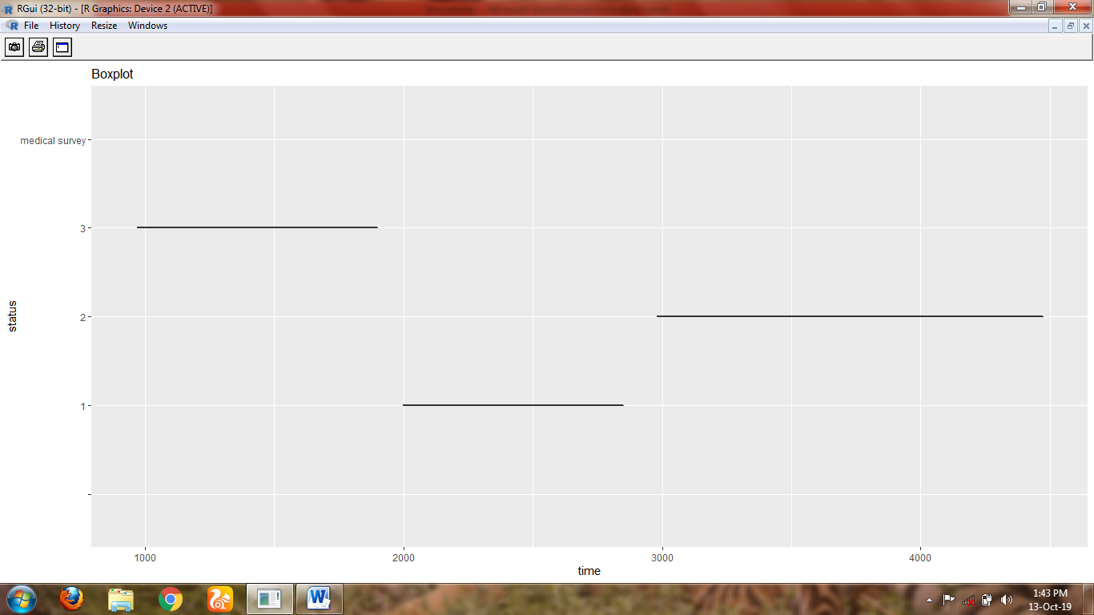

data %>%

+ ggplot(aes(x=status,y=sex,fill=status))+geom_boxplot()+ggtitle("Box plot")

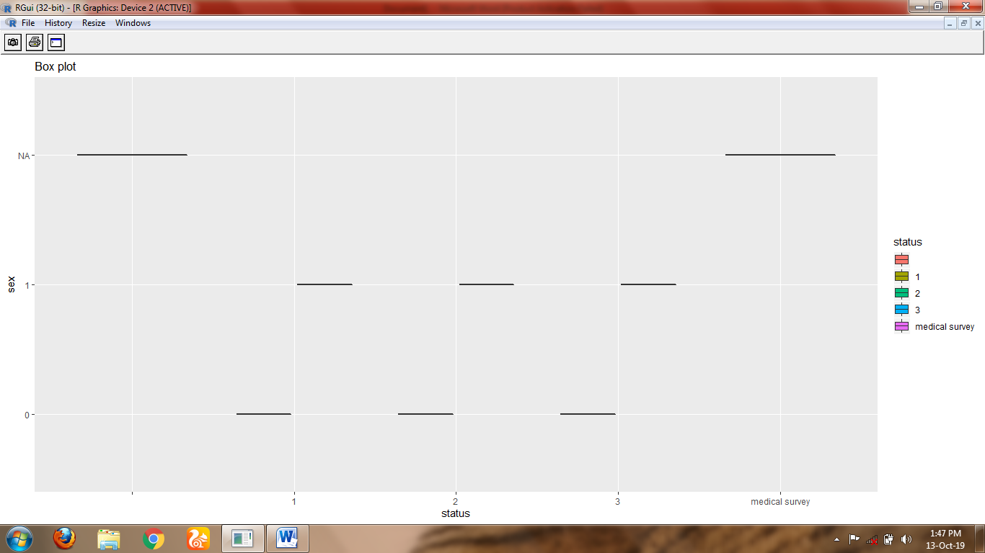

data %>%

+ ggplot(aes(x=sex,y=age,fill=sex))+geom_boxplot()+ggtitle("Box plot")

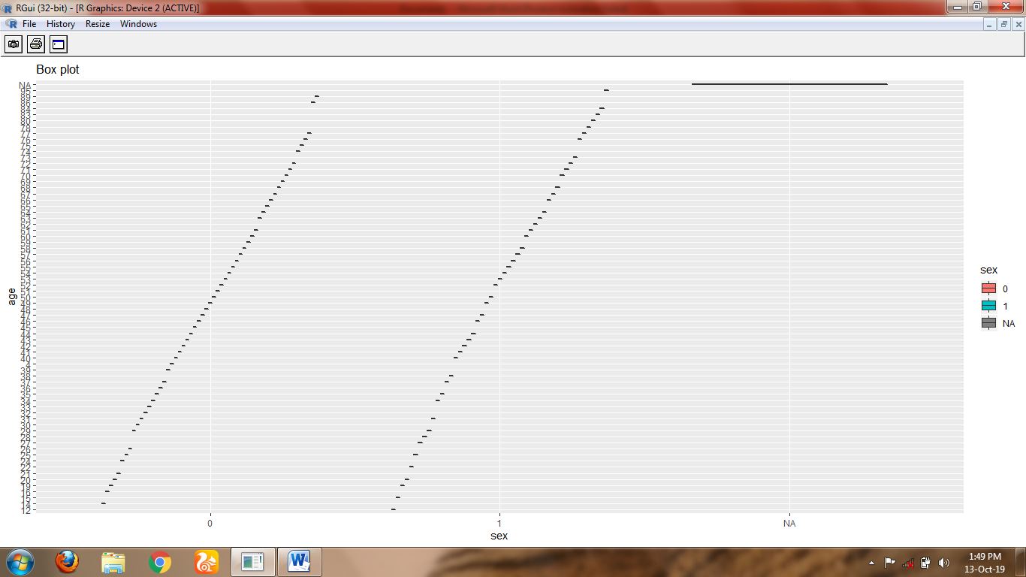

data %>%

+ ggplot(aes(x=sex,y=year,fill=sex))+geom_boxplot()+ggtitle("Box plot")

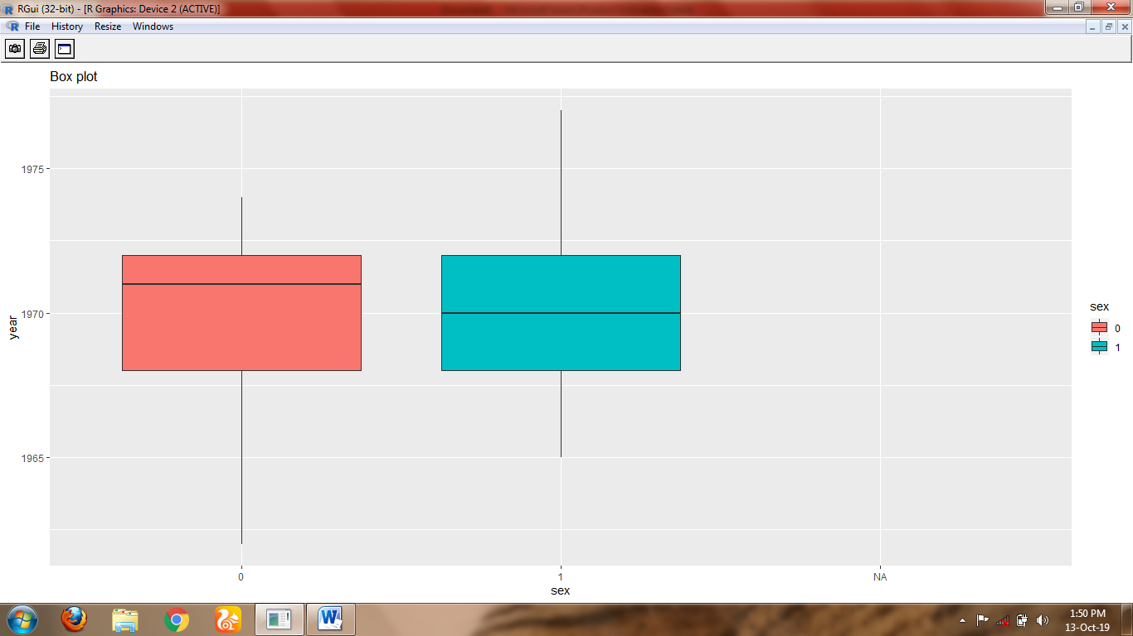

data %>%

+ ggplot(aes(x=year,y=thickness,fill=year))+geom_boxplot()+ggtitle("Box plot")

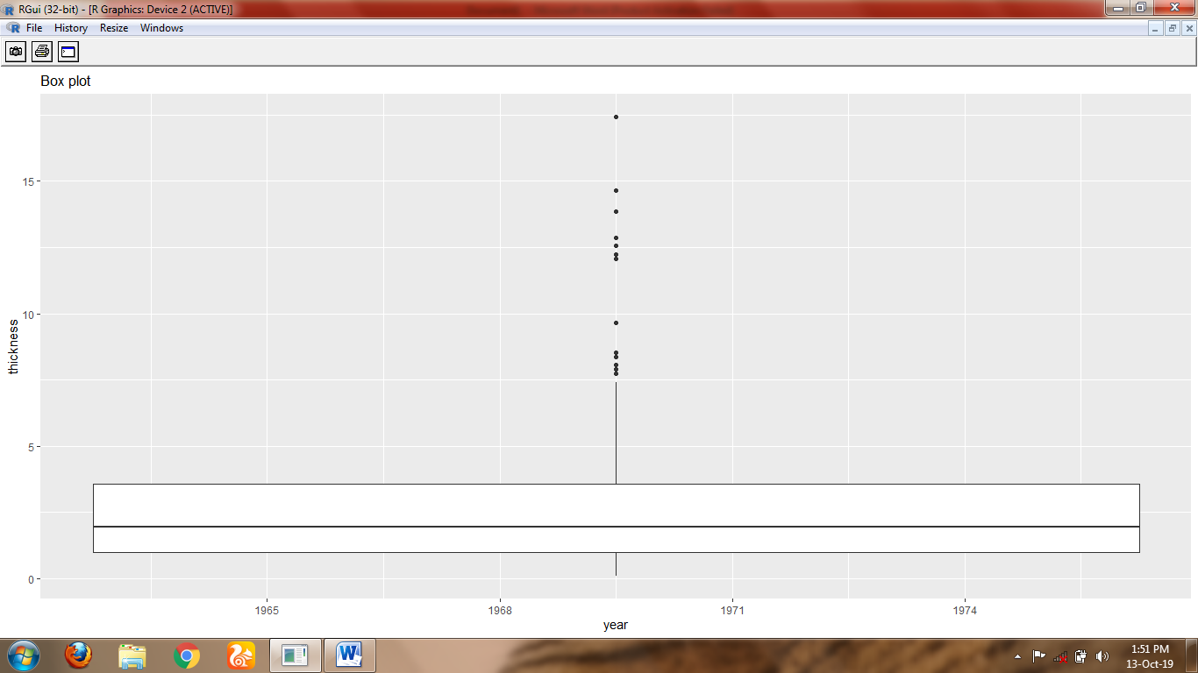

data %>%

+ ggplot(aes(x=thickness,y=ulcer,fill=thickness))+geom_boxplot()+ggtitle("Box plot")

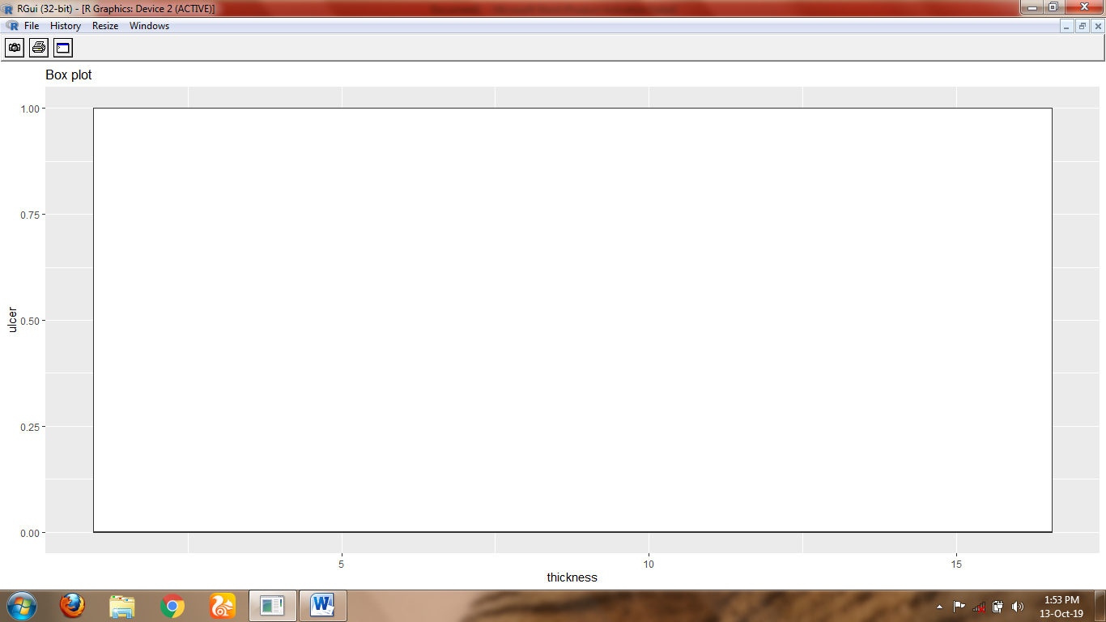

data %>%

+ ggplot(aes(x=ulcer,y=X,fill=ulcer))+geom_boxplot()+ggtitle("Box plot")

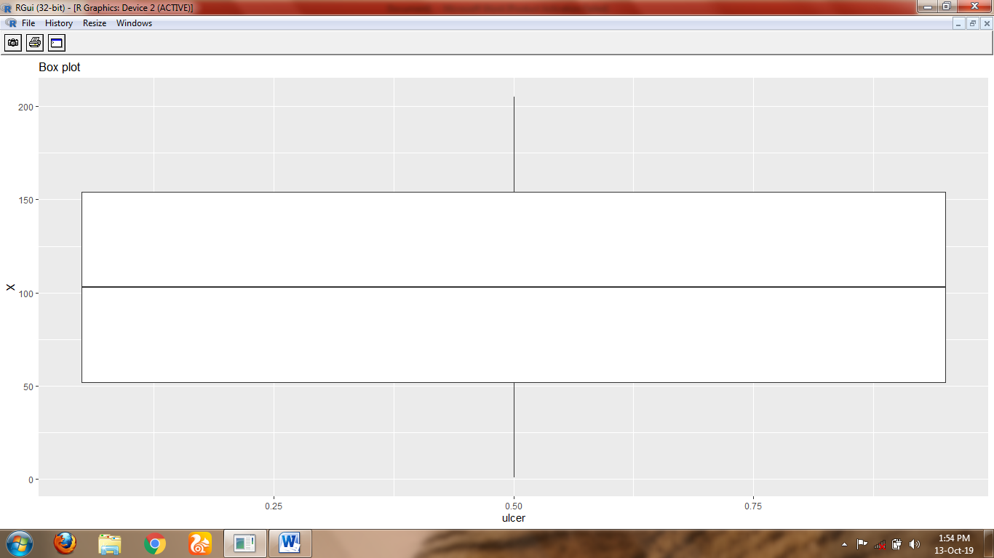

data %>% ggplot(aes(x=time,fill=status))+geom_density(alpha=0.8,color='green')+ggtitle("density plot")

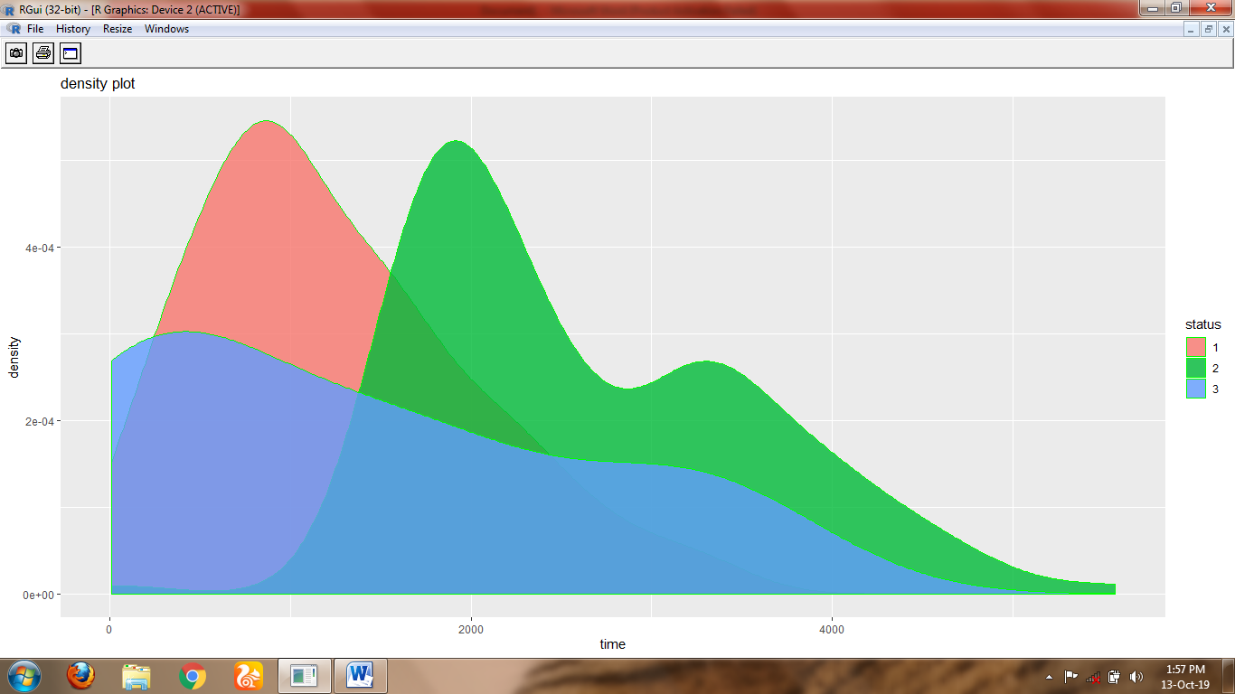

set.seed(1234)

ind<-sample(2,nrow(data),replace=T,prob=c(0.8,0.2))

train<-data[ind==1,]

test<-data[ind==2,]

model<-naive_bayes(status~.,data=train)

Model

model<-naive_bayes(status~.,data=test)

model

(tab1<-table(p1,train$time))

1-sum(diag(tab1))/sum(tab1)

(tab2<-table(p2,test$time))

1-sum(diag(tab2))/sum(tab2)